OpenMV Servo Shield.

Features

  - PCA9685 controller.
  - 8-channel, 12-bit PWM.
  - I2C-bus controlled.
  - Internal power-on reset.
  - Internal 25MHz oscillator
  - Operating supply voltage range of 2.3 V to 5.5 V.
  - Low standby current.

Description

The Servo Shield enables OpenMV cameras to control up to 8 servos in parallel. It features the PCA9685 Servo Controller which also supports general-purpose PWM. The OpenMV software and IDE includes scripts for controlling the chip for general-purpose PWM and controlling servos.

Device Information
PART NUMBER | BODY SIZE (NOM)
OPENMV-SERVO-SHIELD | 1.40 in × 1.05 in

Applications

- Self-driving cars.
- Driving RGB LED.
- Support pan-tilt kits.

.
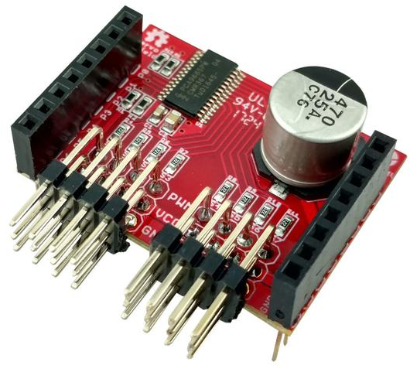

Table of Contents
1 Features 1
2 Description 1
3 Applications 1
4 Pin Configurations and Functions 3
5 Electrical Characteristics 4
5.1 Recommended Operating Conditions 4
6 Mechanical Information 5

Pin Configurations and Functions

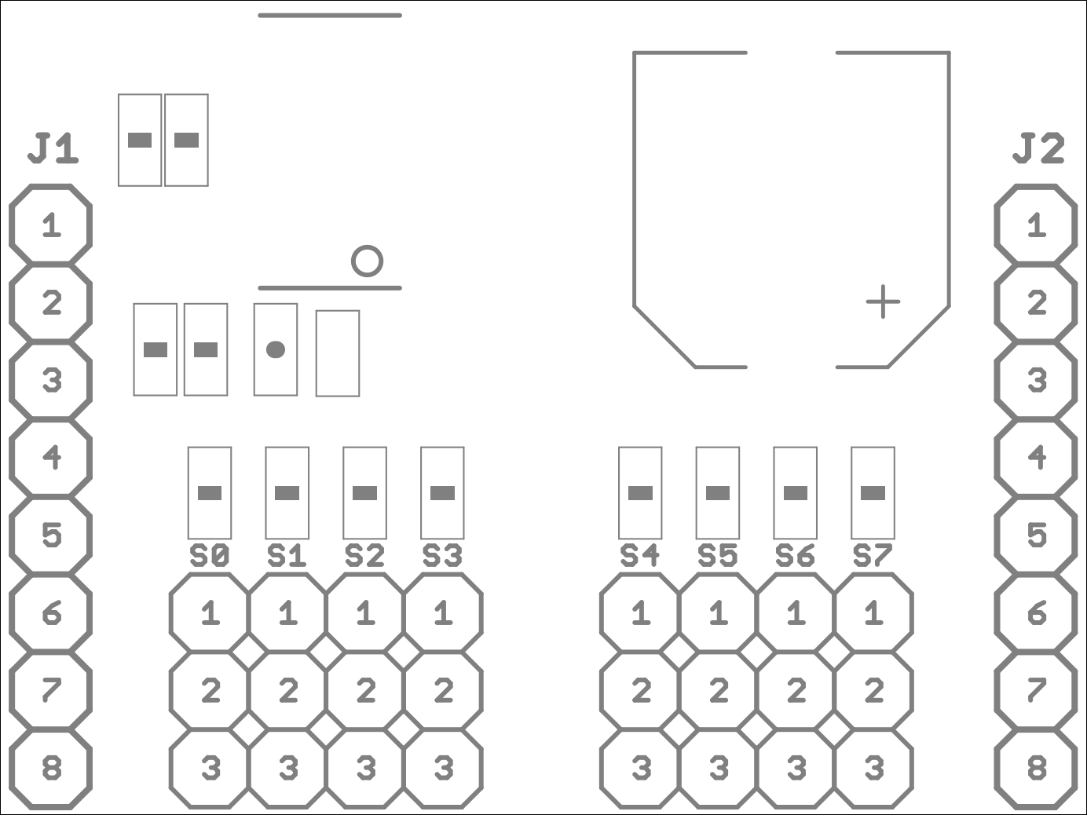

Pin Functions
Pin |  |  | Description
Header | No | Name | Description
J1 Pin Configuration
J1 | 1 | P0 | NC
J1 | 2 | P1 | NC
J1 | 3 | P2 | NC
J1 | 4 | P3 | NC
J1 | 5 | P4 | SCL
J1 | 6 | P5 | SDA
J1 | 7 | P6 | NC
J1 | 8 | 3v3 | PCA9685 supply.
J2 Pin Configuration
J2 | 1 | RST | NC
J2 | 2 | BOOT | NC
J2 | 3 | SYN | NC
J2 | 4 | P9 | NC
J2 | 5 | P8 | NC
J2 | 6 | P7 | NC
J2 | 7 | VCC | Servo input supply
J2 | 8 | GND | GND
S0-S7 Pin Configuration
Sx | 1 | PWM | PWMx
Sx | 2 | VCC | Servo output supply
Sx | 3 | GND | GND

Electrical Characteristics

5.1 Recommended Operating Conditions

SYMBOL | RATINGS | MIN | MAX |  | UNIT
V_{cc} | Servo input supply voltage range. | 4.8 | 6.0 |  | V
V_{3v3} | PCA9685 supply voltage range. | 2.3 |  | 5.5 | V
T | Operating Temperature | -40 | 85 |  | °C

Mechanical Information
The following information is the most current data available for the designated device. This data is subject to change without notice and without revision of this document.

